AM,C-Taino-Fire God

The God of Fire in its characteristic pose (Fewkes 1907

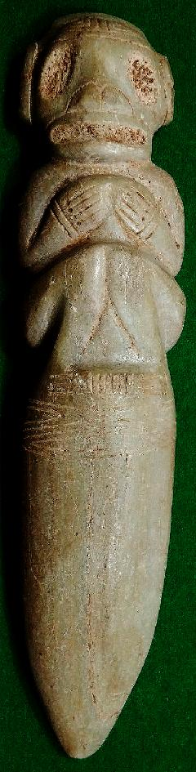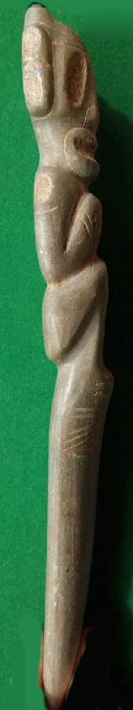 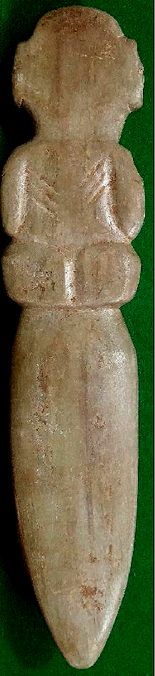

### Delivery package 1 of 1

Estimated delivery Tuesday, Mar 15, 2016 - Tuesday, Mar 22, 2016

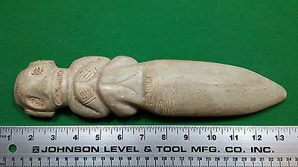

#### [Taino Stone Dagger, Looks like it is made from a Marble Type Stone](http://www.ebay.com/itm/161989517868)

|  |  |
| --- | --- |
| Item price | $199.00 |
| Quantity | 1 |
| Item number | 161989517868 |
| Shipping service | Standard Int'l Shipping |

## Shipping address

Ralph J Coffman Jr

149 Atlantic Ave

Swampscott MA 01907-2427

United States

## Order total

|  |  |
| --- | --- |
| Subtotal | $199.00 |
| Shipping | $19.95 |

**Total**

$218.95